Please fill out the following fields:

|  |  |
| --- | --- |
| Who is the sponsor of this project request? | Jason Krueger |
| Who is the customer of this project? | rms |
| State the problem or opportunity you would like to solve? |  |
| What is the current state – provide additional background about the issue. |  |
| What is the proposal and the goals/deliverables? |  |
| Date needed? |  |
| Potential (internal or external) resources required? |  |
| Estimated cost and benefit? |  |
| What are the risks? |  |
| Impacted stakeholders? |  |
| Potential constraints (time, resources, money, technology)? | Money (it costs us 1$ for each ticket we print. We print several thousand per year.)  Time (it will take far less time to perform the calibration |
| Additional comments to help explain your request better. (Please attach supporting documentation). |  |

Universal Process Notation (UPN):

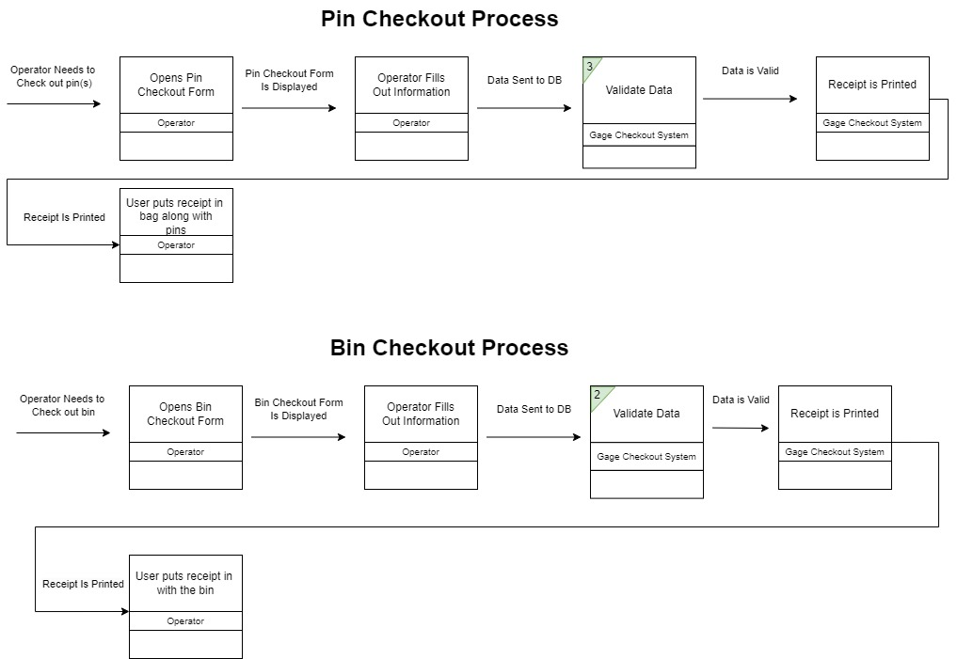

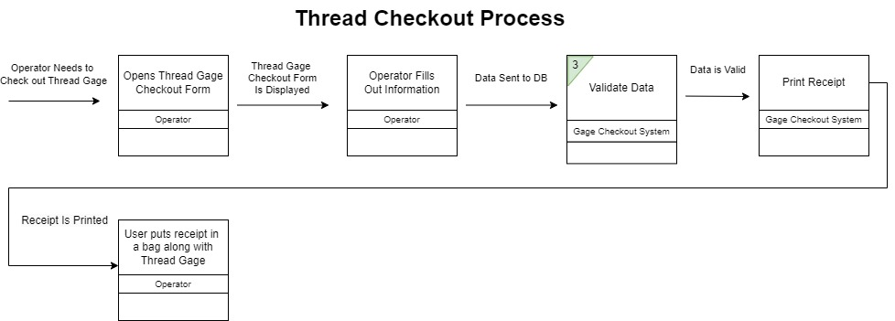

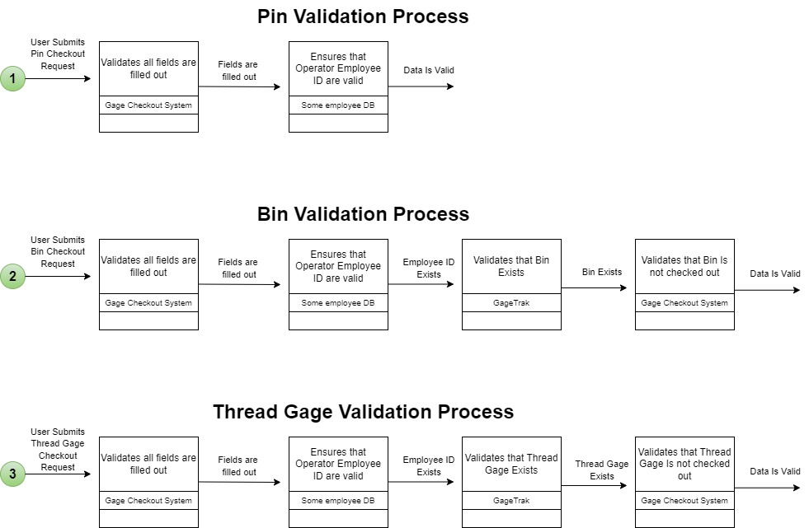

**For IT Use Only:**

|  |  |
| --- | --- |
| Developer |  |
| External Support |  |
| Internal Support |  |
| Business Owner |  |
| IT Owner/BA |  |
| Start Date |  |
| End Date |  |
| Hours Estimate Internal |  |
| Hours Estimate External |  |